Riphah International University Of Lahore

Name:
Hanzla Ahmad

SAP ID:
61002

Subject:
Computer Organization and Assembly Language

Submitted to:
Mrs. Amna Bibi
Lab 1
Task 1

Source Code:
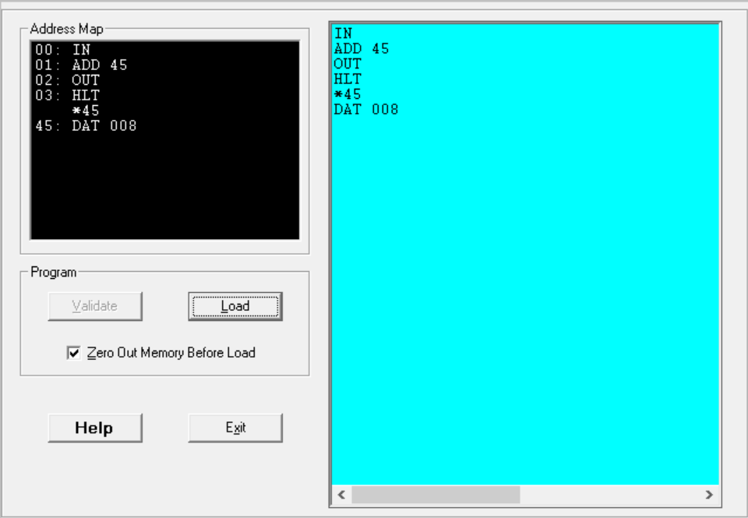

Output:
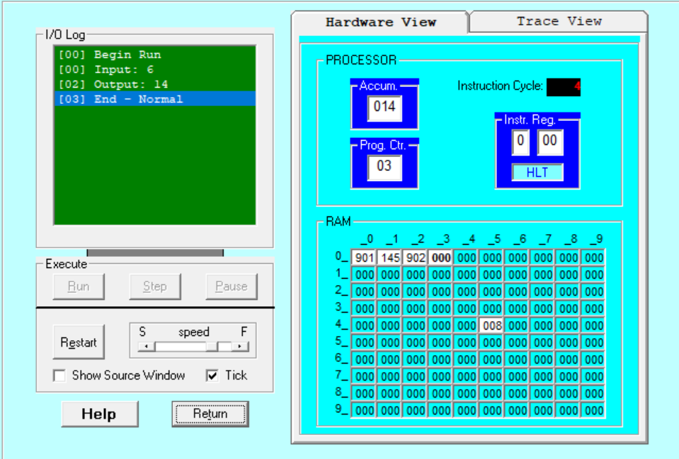
Explanation:
First, we take input and add value at address 45 which is 008 then we’ll print or output the value which is 14 and after that the program will end with “HLT”.
Task 2

Source Code:
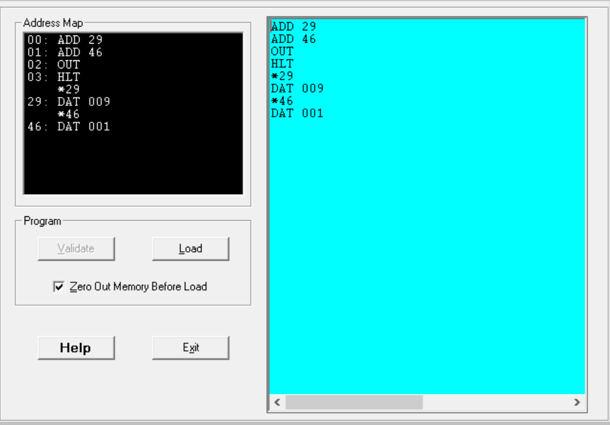

Output:
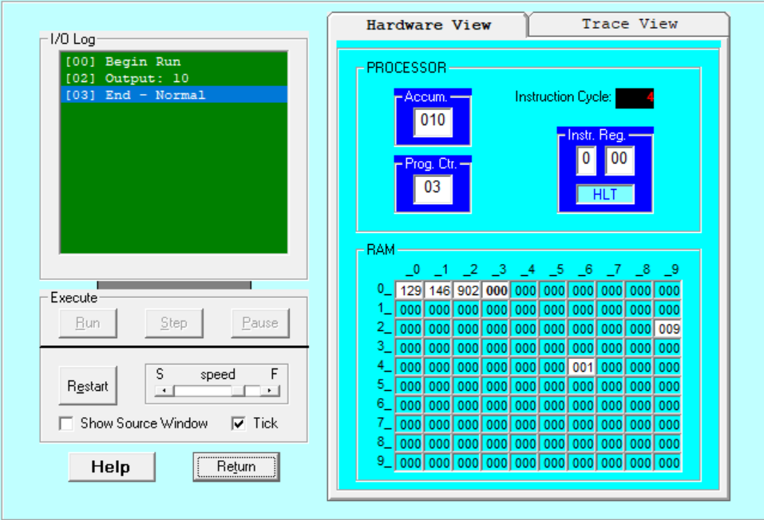

Explanation:
First, we take 2 numbers 29 and 46 hardcoded at address 29 and 46 with values 009 and 001 that will be added and we’ll print it out and the output is 10 and after that program will end.

